Integrated Management Information Systems

Data Warehouse
InfoView
Process Guide

Training Guide l Version 8 l June 2010

DCATS 567-7777 Option 5
Table of Contents

About Data Warehouse 3
About this Guide 3
Objectives 3
Logging on to Data Warehouse 4
The Home Page Window 7
Viewing Public Folders 8
Scheduling and Running a Report 14
Scheduling a report 14
Running the report 19
Viewing a Report 21
Exporting Reports to Excel 22
Printing a Report 24
Deleting a Report 26
Navigating in the Crystal Report Viewer 27
Exiting a Report and Data Warehouse 27
Docid Prefixes: 28

About Data Warehouse
Data Warehouse is a special database that contains institutional and departmental data. Initially, financial data will be accessible using Data Warehouse. Future uses and functionality of the Data Warehouse are planned and will be added to this process guide when they become available to the users.

The data is accessed using Crystal Reports through a web application called InfoView. Learning CR software is a step toward becoming familiar with the Data Warehouse and its benefits.

The information data comes from the Accounting files. You cannot damage or delete any information when you schedule these reports.

This application will work a Macintosh computer and a PC using other browsers (Including but not limited to: Internet Explorer, Mozilla, Firefox, Safari).

To receive access to Data Warehouse, two forms must be submitted:
1. The Access Control Executive (ACE) of your department needs to send a Personnel Security Access Request form (PSAR) with approval for access.
2. An Authorized Signatory or the ACE must also send in an SRF to Computing Resources to purchase a Data Warehouse license with a one-time fee of $250.00. If this employee should transfer to another department, the license will remain within the department. This vacant license can be transferred to another employee.

About this Guide
In the training class, this guide will use a training environment that is only accessible while in the training classroom. Data that is accessed during training has been recreated to demonstrate the objectives of this class.

You will also use this guide, using your own departmental data, to run reports in your department.

Objectives
You will learn:
- to log on to InfoView using Internet Explorer
- to schedule, view, export, and print a report
- to log off and exit

Logging on to Data Warehouse

- Open an Internet session by clicking on the Internet Explore icon on your desktop.

- Sign into the portal using your Domain ID and password.
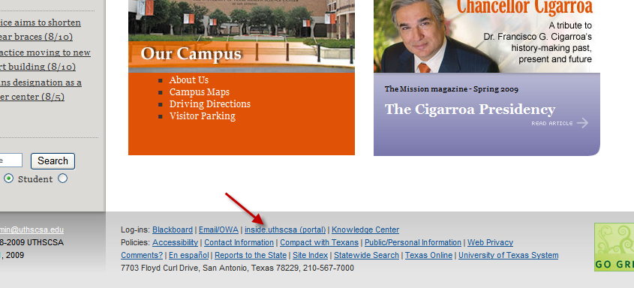

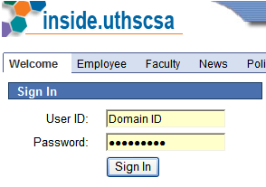

- Click on HSC Business Applications within the Enterprise Menu

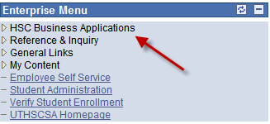

- Click on the Data Warehouse link within the menu options

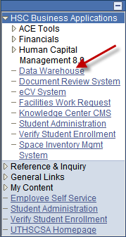

This will bring you to the Data Warehouse sign in screen.

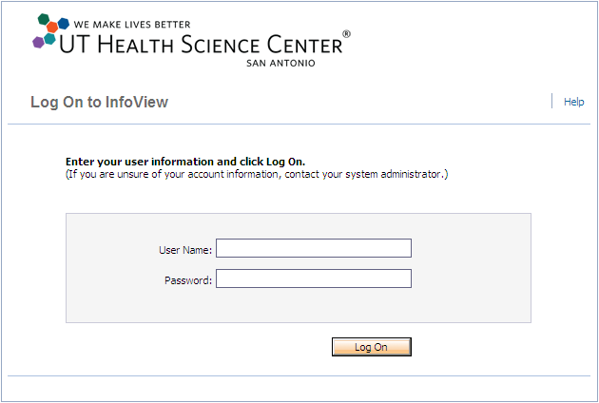

To create a shortcut icon on your desktop (one-time set up), right click on the sign in page to get a drop-down menu.

- Select “Create Shortcut” and click OK. This will place an icon on your desktop named “BusinessObjects” (which can be renamed to “DW”, for example). Or, you may add it to your Internet Explorer Favorites.

- Use this icon to access the Data Warehouse.

Be advised: When you log into the NEW Data Warehouse environment, you will be accessing a web browser.

This environment session will expire after 20 minutes of inactivity.
In the User Name and Password boxes, type your Domain ID and password.

Click the Log On button.

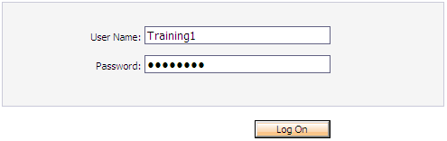

The Home Page Window

Once you begin running reports, you may click on Home to return back to the home screen.

which is located on the left side of your menu

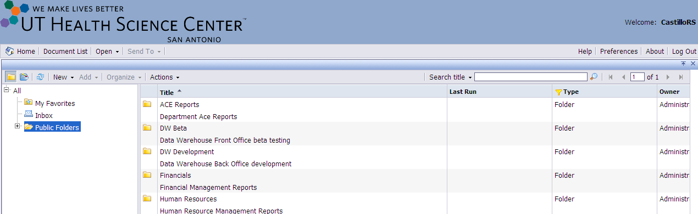

*Note: It is not advised to use the navigational arrows when attempting to go back to a previous screen.

Currently the Open and Sent To links are not being used.

Viewing Public Folders

To see the reports available for your use, click on one of the available folders to display its contents.

Select Public Folders to view additional Folders

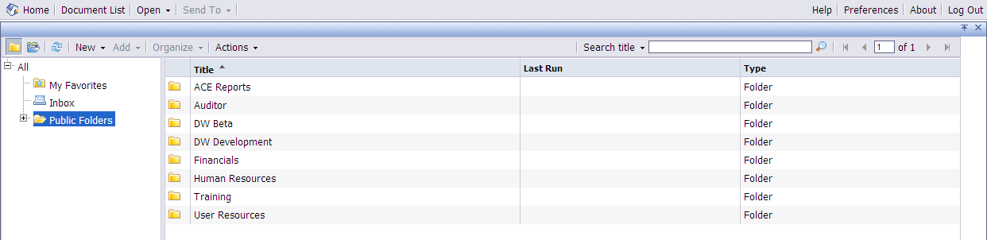

Click on the Financials link to see additional folders to access the Transaction Detail and Summary Folder.

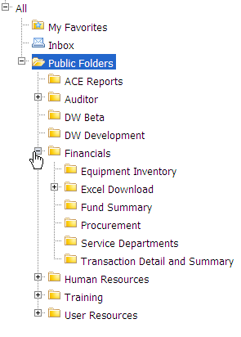

A submenu of folders will appear within the left menu and will also expand to the right panel.

To view the available ACE Reports, double click the ACE reports folder on either menu.

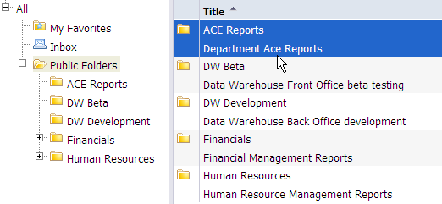

Currently Ace Reports can be retrieved by any data warehouse user within the department.

ACE Report names and descriptions

HR Pay Data User List
- Provides a list of Human Resources Pay Data Report Users for a department(s).

Requisition Security-Administrators
- Provides a list of PeopleSoft Financials Administrator Approvers for a department(s)

Requisition Security-Project Managers (DeptID)
- Provides a list of PeopleSoft Financials Project Managers for a department(s)

Requisition Security-Project Managers (Project)
- Provides a complete list of projects (across departments) for a Project Manager

Requistion Security-Requestors
- Provides a list of PeopleSoft Financials Requesters for a department(s)

To view the available Financial Reports, double click the Financials folder on either menu.

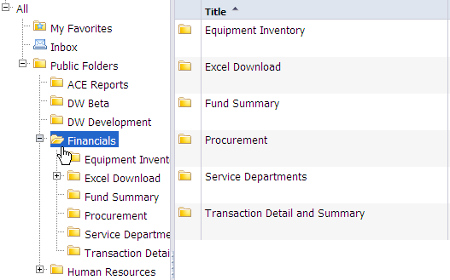

Depending on your access requested by the Departmental ACE, the following list of reports will be available under the Financials folder.

Financials reports and sub reports names and descriptions

Equipment Inventory

Property Inventory – Department Report by Selected Location(s)
- View Dept Assets and physical location of assets by specific building code

Property Inventory – Department Report by Selected Location
- Listing of all assets. Contains a physical location column for a DeptID

Property Inventory – Department Report by Location
- Similar to report above, listing of all assets, no physical location column, is sorted by location with building heading

Excel Download

DW Excel Export
- Detailed view of transactions that affect the free balance of a project. Includes grant budget entries.

DW Excel Export (Combined)
- Combination of Excel Export and Contract Rec.

DW Excel Export (Contract Receivables)
- Detailed view of grant budget entries and grant income entries.

DW Excel Export (Project)
- Attributes of all projects, including fund code, DeptID, PI, end date, etc.

Fund Summary

Fund Summary-General
- Report will summarize general funds transaction data to the Budget Category level.

Fund Summary-Other
- Report will summarize other funds transaction data to the Budget Category level.

Fund Summary-Plant
- Report will summarize Plant funds transaction data to the Budget Category level.

Fund Summary-Restricted
- Report will summarize restricted funds transaction data to the Budget Category level.

Procurement

Procurement DocID Report
- This report is a cross-reference of the documents involved in the procurement of an item sorted in date order. In this report, the general stores transactions can be clicked on to reveal the details or breakdown of that transaction.

Requisition Security-Administrators
- Provides a list of PeopleSoft Financials Administrator Approvers for a department(s)

Requisition Security-Project Managers-DeptID
- Provides a list of PeopleSoft Financials Project Managers for a department(s)

Requisition Security-Project Managers-Project
- Provides a complete list of projects (across departments) for a Project Manager

Requisition Security-Requesters
- Provides a list of PeopleSoft Financials Requesters for a department(s)

Requisition Not Sourced to a Purchase order
- The Requisitions Not Sourced to a Purchase Order report shows when a requisition was entered, who entered it, and when the goods or services are/were needed.

Service Departments

General Stores Inventory Transactions Report
- This report contains an item level breakdown for each of the "General Stores IN0000xxxx" transactions that appear on the DTL and Monthly ledger reports. The "IN" transaction is broken down to the item level on this report. The reference point for this report is the Doc ID.

LAB Animal Payment
- Restricted to Lab Animal Personnel.

LAB Billing
- Departments can run this report to view their LAR Billing.

LAB Billing (Excel Export)
- Departments can run this report to view their LAR Billing in an Excel format.

Transaction Detail and Summary

Contract Receivables Report
- This report contains deposits made to grant and contract projects and the project's account receivable balance based upon the original contract amount. Please note: This monthly report will not generate output for any month without recorded transactions for that month.

DTL Report – Daily Transaction Listing Report
- This listing contains a high level of financial detail by post date. It is sorted on DeptID, ProjectID, and then Budget category. In this report, the general stores transactions can be clicked on to reveal the details or breakdown of that transaction.

EC MFR
- Restricted Report for Dean’s & VP Offices.

Encumbrance Report Detail
- Lists outstanding Encumbrances and Pre-Encumbrances.

Grant Ledger Summary
- This report consolidates the information provided in the Monthly Ledger Summary report with the information in the Contracts Receivable report.

Monthly Ledger Report
- This report contains a high level of detail summarized by date, then by DocID (Purchase Order number). It contains transactions sorted by: DeptID, ProjectID, and Budget category. In this report, the general stores transactions can be clicked on to reveal the details or breakdown of that transaction.

Monthly Ledger by DocID Report
- This is the Monthly Ledger (detail) report that displays transaction totals, by DocID, without displaying the individual line item detail. In this report, the general stores transactions can be clicked on to reveal the details or breakdown of that transaction.

Monthly Ledger Summary Report
- This report is a high level summary of accounts by DeptID, ProjectID, and includes totals by Budget category.

MSRDP Operating Report
- This is a report specifically designed for medical departments practicing at UTMSA

To view the available reports listed under the Human Resources section, double click the Human Resources link.

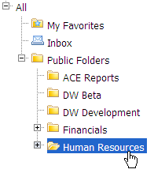
Depending on your access requested by the Departmental ACE, the following list of folders and reports will be available under the Human Resources folder.

Human Resources Folder names and descriptions:

Human Resources folder names and descriptions

Appointment Activity

Benefits

Employment Activity

HRDMBeta

Pay
Hrdm_PayListing Excell Export
- This report provides a detailed listing of all payrolls processed for the current fiscal year by Employee IDs, Employee names, Project IDs, Earnings Codes and dollar amounts paid. When this report is run it is automatically exported into Excel.

Hrdm_PayListing Report
- This report provides a detailed listing of all payrolls processed for the current fiscal year by Employee IDs, Employee names, Project IDs, Earnings Codes and dollar amounts paid. When this report is run it is automatically exported into Crystal.

Personal Data

Staff Benefits OASI Report
- This report is a listing of staff benefits by employee. The legacy accounts are currently being used in this report.

Staff Benefits VAC Report
- This report is a listing of staff benefits by employee. The legacy accounts are currently being used in this report.

Scheduling and Running a Report

Scheduling a report

When you schedule Data Warehouse reports, do not schedule reports between the hours of 5:00 am to 8:00 am. The system will be updating data during these hours and data on your report will not be accurate. Any changes made up to 5:00 pm of the current day, will not show on the Data Warehouse reports until the next working day. All reports are scheduled using the steps below.

- Move the mouse pointer over the Daily Transaction Listing (DTL) selection and Right Click to view the drop-down menu.

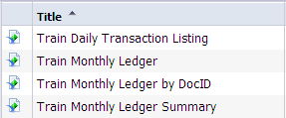

- Click on Schedule

Be Advised: It is not recommended you run the report by double clicking on it. Should troubleshooting be needed, the report will only be stored in the History folder by using the right click scheduling option.

*Note: User will have the ability to run a report in “View” but will not be saved in the History Page.

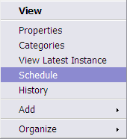

A Schedule Menu with settings will appear on the left.

- Click the Parameters link in the left-side menu: This will populate options on the right view panel to enter the criteria for your report.

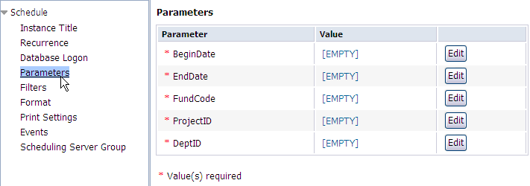

Click the button to specify the parameters for your report. All fields are notated as Required by an asterisk.

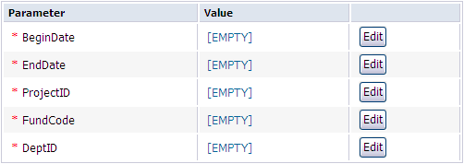

- Select the calendar icon to display the calendar. Select your begin date and click OK.

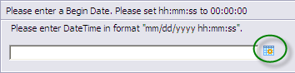

*Note: When running the monthly reports select the fiscal year not calendar year.
Example: Information for September 2008, resides within fiscal year 2009.

You MUST click the OK button again on the bottom right. If this step is not completed, the report will fail.

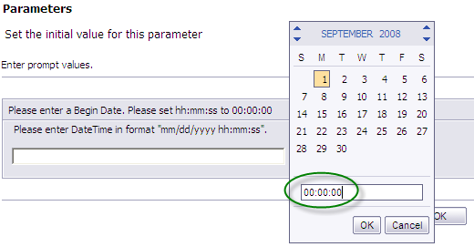
**Notice the Time Stamp. The HH:MM:SS should always indicate 00:00:00**
Once you click the OK button, you will return to the parameter screen and the Current value should now reflect the BeginDate you selected for the report.

- Repeat the steps for the EndDate section of the required parameters.

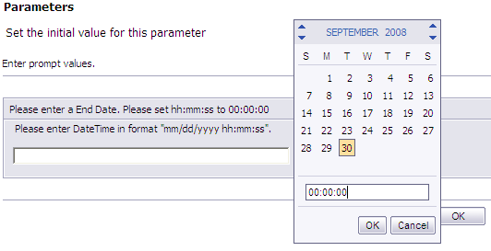

**Notice the Time Stamp. The HH:MM:SS should always indicate 00:00:00**

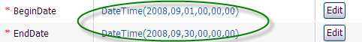

- In the Prompt Project ID, select ALL Projects and click the right directional button . Click OK to set the value. If you want to specify a project id number, enter the number into the Enter a Value field and click on the right directional button , Click OK to set the value.

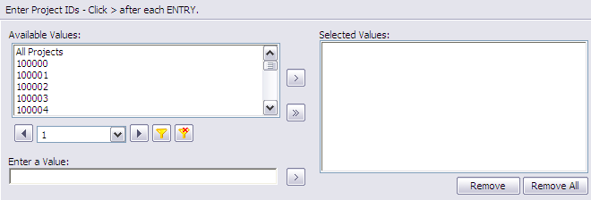

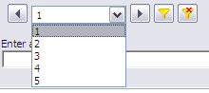

- Use the Drop down menu to navigate through multiple pages, if a user has access to several Project ID’s and Department ID’s.
- Use the Filter icon to filter and search through the Project ID’s and Department ID’s.

- In the Prompt Fund Code, select All Funds and click the right directional button .
Click OK to set the value. If you want to specify a fund value, enter the number into the Enter a Value field and click on the right directional button Click OK to set the value.

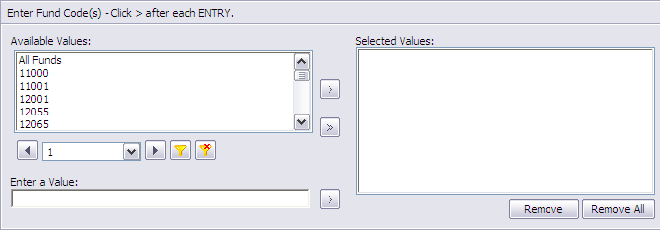

- In the Prompt DeptID, select ALL Departments and click the right directional button . If you want to specify a DeptID number, enter the number in the Entre a Value field and click on the right directional button , Click OK to set the value.

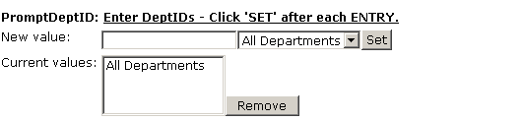
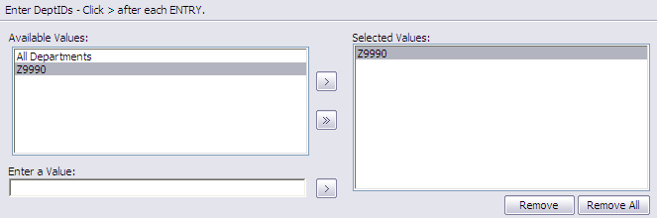

*Note: When entering a Department Id in the Enter a Value field, you must use uppercase letters. This field is case sensitive. (Example: Enter Z9990)*

To remove any of the above fields, highlight the desired Project ID’s, Fund, or Department ID and select the Remove button. To remove all values, click the Remove All button.

Running the report

After verifying all values have been set, click on the Schedule button at the bottom right side of the page to schedule your report to view.

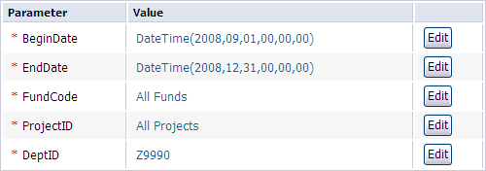

The History Dialog box appears and shows you the status of the report.

You will see Pending, Success, or Failed for each report run. For a report that has the Status: of Pending, click on the Refresh button in the top right mid-section of the History dialog box until you receive a success.

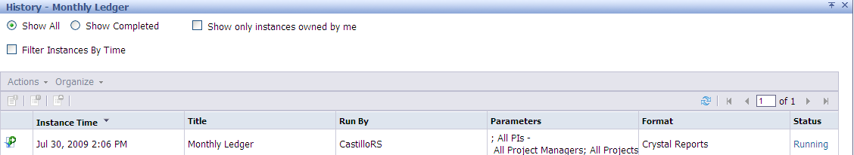

You will see only your own instances. There is a limit of 45 days the instances will appear in the History dialog box per each report.

If the report has a status of “Failed”, click on the “failed” status. This will provide a brief description for the failure. If the error message reads, “Information is needed before this report can be processed”, criteria may not have been confirmed.

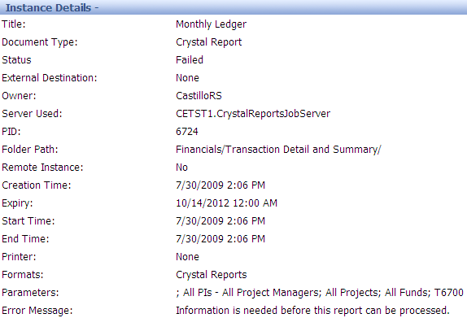

Viewing a Report

Viewing the Daily Transaction Listing

- From the History Dialog box, move your mouse to a “Success” report instance and click on the Instance Time:

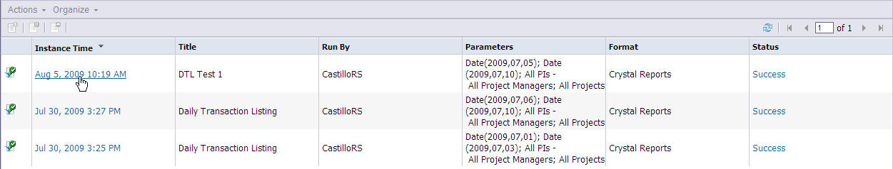

- A sample of what the Daily Transaction Listing will look like is shown below. You will only see the DeptID(s) you have been given access to on the Main Report Group Tree panel.

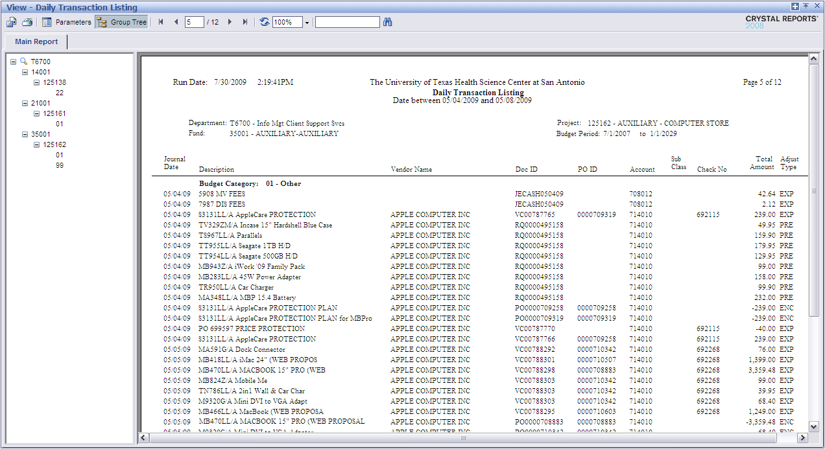

Exporting Reports to Excel

Exporting a file is useful when the data needs to be in a particular format, such as Excel. The particular method below is used when the report has been run in Crystal Report, and you are exporting it into Excel format.

*Note: When reconciling accounts for Internal Audit, you must use the Crystal Report or Adobe Acrobat format which cannot be manipulated or sorted.

- Click the Export Button on the toolbar.

- Select Excel in the Save as type.

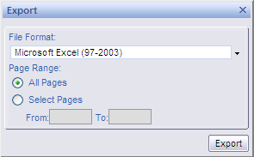

*Note: You have the ability to export the entire report or select particular pages (i.e. From 1 To 5)

- Click Export to complete the file export.

- When the report is exported, a file download box appears.
  - Click Open to open the report in Microsoft Excel
  - Click Save to save the report in a folder.

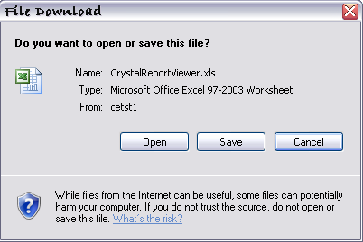

Closing the Excel file returns you to the crystal report.

Printing a Report

When printing a report, you cannot change the report’s orientation. When printing to a printer other than your default, you must first change the settings in the control panel to the printer of your choice.

- To print, click on the printer icon on the menu bar of the InfoView toolbar.

- A Security Warning will prompt the user to install a Print Control for Business Objects application. It is only necessary to install this application one time, and the user will need to be set up as Administrator on the computer. Click on the More Options button to select “Always install software.”

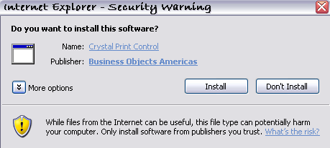

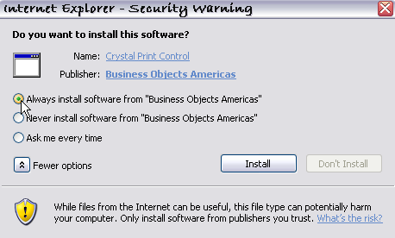

- After installation, The Print Dialog box will appear. Click the Properties button and verify the orientation is set to Landscape.

- Click OK, this returns you to the Print Dialog box.

- The amount of pages to be printed will default to “ALL”. To print select pages, click on the “Pages” option and enter the beginning page number and the ending page number you want to print. (i.e. 1-5).

*Note: The printer will default to “Microsoft XPS Document Writer,”

- Select the printer within the drop down menu.

- Click PRINT (or OK, depending on your Print Dialog box) when you are ready to print.

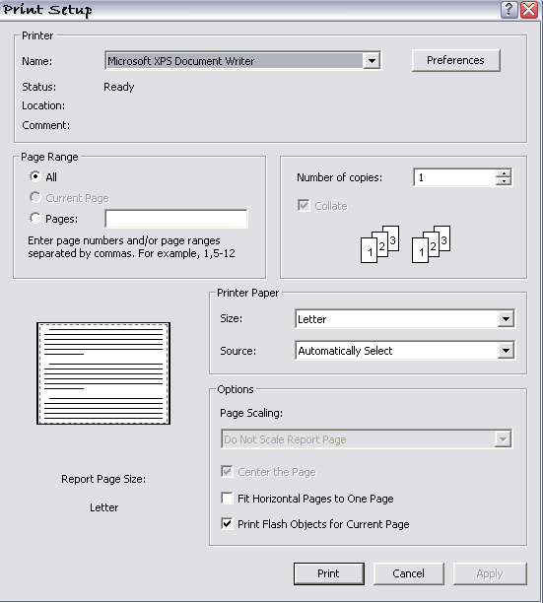

Modify Parameters in Report

While the report is open, you have the ability to modify parameters that were set during the scheduling of the report. Select the Parameters button within the tool bar to view the Parameters menu.

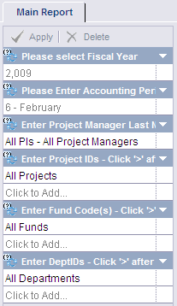

You may change the following options: Fiscal Year, Accounting Period, Project Manager, Project ID’s, Fund Codes, and Dept ID’s.

To change the Accounting period, select the drop down arrow at the end of the field and select an alternate Accounting Period.

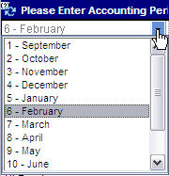

*If any changes were entered, the Apply button will activate. Select apply to confirm the changes.

The new report will not override the current report or create a new instance time in the history page.

Deleting a Report

To delete a report from your History box, one at a time, highlight the report and click on “Organize.” The “Delete” button will appear, click Delete.

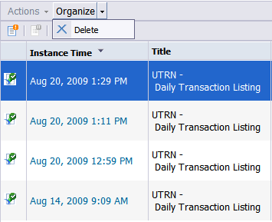

A confirmation dialog box will appear. Select “OK” to delete report or cancel to disregard the delete.

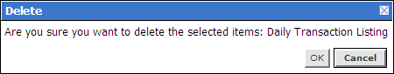

You can also delete several instances at one time by holding the CTRL key and clicking the reports needing to be deleted. Click the Organize button then the delete button.

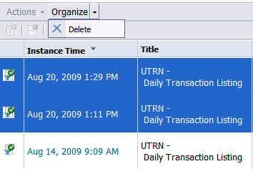

Navigating in the Crystal Report Viewer

You can navigate through a report using the Crystal Report Viewer Menu Bar buttons. Below you will see an overview of the toolbar icons.

Hint: To quickly move to a specific page, click in the “current page” box. Enter a page number and press Enter on the keyboard.

First Page Previous Page
Next Page Last Page
Current Page box
Print Report
Refresh
Toggle Group Tree
Export Report
Search Text
View Scale
Close Current View
Open in New Window

Exiting a Report and Data Warehouse
To Exit a report in the Crystal Report Viewer, click on the “X” in the upper right hand corner of the window.

To Exit from the UTHSCSA Data Warehouse system, click on the Log Out link on the menu bar.

To close Internet Explorer, click on the “X” in the upper right hand corner of the window

Docid Prefixes:

DocID Prefix | Document | Support Documentation | E-Mail | Correction Request | E-Mail
JECR | Cash Receipts Voucher | Accounting | Acct-Admin@uthscsa.edu | Accounting | Acct-Admin@uthscsa.edu
IT | Manual IDT | Accounting | Acct-Admin@uthscsa.edu | Accounting | Acct-Admin@uthscsa.edu
IT | Automated IDT:
 | Invoice/Bill | T & N | Pinnteam | Accounting | Acct-Admin@uthscsa.edu
 | Invoice/Bill | Print Services | MolinaS@uthscsa.edu OchoaJ@uthscsa.edu | Accounting | Acct-Admin@uthscsa.edu
 | Invoice/Bill | Postage | REINA@uthscsa.edu | Accounting | Acct-Admin@uthscsa.edu
 | Invoice/Bill | Computing Resources | Triage@uthscsa.edu | Accounting | Acct-Admin@uthscsa.edu
 | Invoice/Bill | Linen Services | Pritchett@uthscsa.edu | Accounting | Acct-Admin@uthscsa.edu
 | Invoice/Bill | Lab Animal Research | Kmoore@uthscsa.edu | Accounting | Acct-Admin@uthscsa.edu
JE | Non-Voucher Entries | Accounting | Acct-Admin@uthscsa.edu | Accounting | Acct-Admin@uthscsa.edu
JV | Payroll transfers | Payroll | Pay-Admin@uthscsa.edu | Payroll | Pay-Admin@uthscsa.edu
JEPV | Petty Cash | Accounting | Acct-Admin@uthscsa.edu | Accounting | Acct-Admin@uthscsa.edu
PR | Payroll | Payroll | Pay-Admin@uthscsa.edu | Payroll | Pay-Admin@uthscsa.edu
VC | Vouchers & AP corrections | Accounting | Acct-Admin@uthscsa.edu | Accounting | Acct-Admin@uthscsa.edu
PO | Purchase Orders | Department | UTHSCSA Inside Portal | Accounting Purchasing | Acct-Admin@uthscsa.edu Purch-Admin@uthscsa.edu
RQ | Requisitions | Department | UTHSCSA Inside Portal | Accounting Purchasing | Acct-Admin@uthscsa.edu Purch-Admin@uthscsa.edu
RQ | Travel Requisition | Department | UTHSCSA Inside Portal | Accounting | Acct-Admin@uthscsa.edu
IN | Inventory/General Stores | General Stores | Generalstore@uthscsa.edu | Accounting | Acct-Admin@uthscsa.edu
JVITP | Pro-card | Purchasing | Procard-Admin@uthscsa.edu | Purchasing | Procard-Admin@uthscsa.edu
SF | Student Financial entries | Bursar's Office | darnell@uthscsa.edu | Bursar's Office | darnell@uthscsa.edu
 | Central Receiving |  | Recv-Admin@uthscsa.edu

